

**COMSATS University Islamabad (CUI)**

Software Requirement Specification  
(SRS DOCUMENT)

for

**Child vaccination and growth tracking system**  
Version 1.0

***By***

**Shariq Ahmed CIIT/SP18-BCS-151/ISB**

**Umar khalid CIIT/SP18-BCS-164/ISB**

***Supervisor*Dr. Ashfaq Hussain farooqi**

*Bachelor of Science in Computer Science (2018-2022)*

Revision History

|  |  |  |  |
| --- | --- | --- | --- |
| **Name** | **Date** | **Reason for Changes** | **Version** |
|  |  |  |  |
|  |  |  |  |
|  |  |  |  |
|  |  |  |  |
|  |  |  |  |
|  |  |  |  |

Application Evaluation History

|  |  |
| --- | --- |
| **Comments (by committee)**  **\*include the ones given at scope time both in doc and presentation** | **Action Taken** |
| From where the data about children's and polio teams will be taken. | Children data will be taken by my friend’s hospital |
| Who will be the owner/Stakeholder of the project that will manage it ? | Stakeholders can be government body or any organization under govt. |
| Info about vaccines ? | Info about vaccines means details information about vaccine like whats the purpose of this vaccine, why we use this vaccine etc. |
| Module 5 will be a building a Data Warehouse for DSS ? | No, we wont build data warehouse. We will not have that much data for a data warehouse. |
| Where is the use of AI ? | AI is used in future prediction models |

Supervised by

Dr. Ashfaq Hussain Farooqi

Signature______________

**Table of Contents**

Revision History i

Application Evaluation History ii

1. Introduction i

1.1 Purpose i

1.2 Scope and Modules i

1.2.1 Modules i

a. Module 1: Centralizing and Tracking Child Record i

b. Module 2: Vaccine Center Management: ii

c. Module 3: User Management ii

d. Module 4: Growth Tracking ii

e. Module 5: Decision Support System iii

2. Overall Description iii

2.1 Product Perspective iii

2.2 Operating Environment iii

2.3 Design and Implementation Constraints iii

3. Requirement Identifying Technique iv

3.1 Use Case Diagram iv

3.2 Use Case Description ix

4. Functional Requirements xliv

5. Non-Functional Requirements lxx

5.1 Reliability lxx

5.2 Usability lxx

5.3 Accessibility lxx

5.4 Compatible lxx

5.5 Security lxx

6. External Interface Requirements lxx

6.1 User Interfaces lxx

6.2 Software Interfaces lxxiv

6.3 Hardware Interfaces lxxiv

6.4 Communication Interfaces lxxiv

7. Project Gantt Chart lxxiv

8. Conclusion lxxv

9. References lxxv

10. Plagiarism Report lxxv

# 

# Introduction

This document is about all the specification of requirements in detail for our project “Child immuinization and growth tracker”. In start, purpose and scope of our project is defined that how is beneficial. Then overall description will briefly describe the whole idea of the project. After that Usecases diagrams are used to explain each actor and its features. Next are the definition of these diagrams in details. In that tabular usecases all the details will be mentioned. After that functional and non-functional requirements are mentioned. Audience is defined after that we’ll conclude the whole document.

## Purpose

Child immuinization and growth tracker will be a system that will automate the existing immunization system of Pakistan. Apart from that, it can help parents to monitor their child growth. This system has 4 major parts i.e. Child Vaccination management, Vaccine stock management, Predictions regarding cases and stock and child growth tracking. It will help the authorities to track and eradicate the diseases like polio, TB etc. Also, it will help parents to check their child is growing properly or not.

## Scope and Modules

Child immuinization and growth tracker will automate the existing manual immunization system and it will help authorities to control the spreadness of diseases which are eradiated in all over the world. Apart from that, it will help authorities to manage their stock efficiently so there wont be shortage of vaccines anytime. Parent will also get benefit using this system. They can monitor their child growth. System will be composed of web and mobile application.

## Modules

## Module 1: Centralizing and Tracking Child Record

This is the module in which child data will be inserted into the system. Then system will produce two printable. i.e., birth certificate and schedule of vaccination.

Then whole vaccination schedule will be sent to user via SMS. System will auto generate a reminder before one day of the upcoming vaccination. When the parents will come to any hospital or vaccination center, sub-admin will search child by parent or child id and after vaccination they will update the status of that vaccine. To ensure the activity of the worker, a confirmation code will be sent to parent via SMS. After confirming the status of the vaccine will be updated. System will also keep check if the child did not get vaccinated, parent will get reminder on SMS.

Sub-admin (hospital) can update the incoming stock of vaccine and he can request vaccination center or admin for stock.

## Module 2: Vaccine Center Management:

This module is tackling vaccine related things. Sub-admin (vaccine center) will insert vaccine stock information. Then on the basis of need this stock will be allocated to different hospitals or areas by the sub-admin. Sub-admin can use the system which can predict the upcoming requirements of stock based on past data or birth rate using a customized prediction model.

Sub-admin can make new campaigns and these campaigns can be overview by admin too. Sub-admin can allocate workers, vaccine stock to the campaign. Apart from that, registered parents will get notified by SMS through the system.

## Module 3: User Management

This is a mobile based module which is going to be handled by end users i.e. Polio worker and parents. Our system will provide them the data of the children born in the allocated area. Polio worker will visit, and they will follow the same procedure of doing vaccination through our system.

Other part of this system is for the parents. This feature is providing record of their children through an app. In this application, they can view their children vaccination status. They can download vaccination completion certificate. Also, this feature will educate parents about vaccination through blogs and stats.

## Module 4: Polio Vaccine Management

This is mobile based module for polio vaccine workers and vaccination. Workers will be allotted their areas, and number of children who has to be vaccinated during the campaign. Workers will visit those specific areas and will do the vaccination of children. After vaccination, workers will take additional data from the parents regarding polio symptoms. On the basis of data provided by parents, System will process the data and will let know the parents about the possibility of polio. Same feature will be present in parents application too where they can add this additional information time to time and system can let them know If their children has any symptom regarding polio. Polio workers will be able to send report regarding vaccinated ,unvaccinated children and possible polio symptomatic children on daily basis.

## Module 5: Growth Tracking

In this module**,** parents will add their child information and thesystem will go through prediction model. This feature will take data of Children from 0-8 year. Upon their data submission, our system will predict the growth of their children. This data will be kept in the app and system will ask parents to update current information of child. Then on conclusion of previous record system will suggest specific diet and things which child has deficiency. This will help the parents to keep check on their child growth.

## Module 6: Decision Support System

This module will provide stats that will be shown to admin in the form of graph and numbers. These stats will be based on city, area, and province. These stats include how much children born, how much vaccinations used, how many children get vaccinated and how many were left.

Another feature of this module is the prediction of cases based on the past data. In this feature, system will use the present and past data of children and cases. And on the basis of these stats, system will predict future possible cases. These predictions will be based on cities and areas. This module will also keep check on the stock requirements in the same way discussed in the vaccine center module.

# Overall Description

This section presents the overall description of the targeted project.

## Product Perspective

Child immuinization and growth tracker is a web and mobile application. This system is available at government level in Canada but not present In Pakistan. We are also enhancing by providing prediction assistance using machine learning. Current manual system is not able to track those cases who are not getting vaccinated. Nor they can manage the vaccine stock properly. So, our system will provide assistance in overcoming all these problems.

## Operating Environment

***OE-1:***The system shall operate on both IOS and Android

***OE-2:***The system shall operate on website

## Design and Implementation Constraints

Following design and implementation constraints are involved in this project:

CO-1: Python language shall be used for prediction models

CO-2: React Js will be used for web user interfaces

CO-3: React Native shall be used for designing mobile user interface.

CO-4: Node.js, Express Js shall be used for server-side implementation.

CO-5: Mongo DB shall be used as the NoSQL Database required for storing and maintaining user records.

# Requirement Identifying Technique

## Use Case Diagram

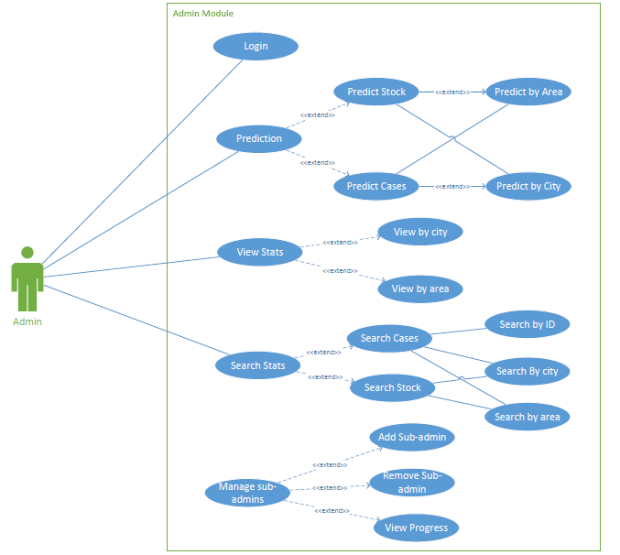

Figure 1: Usecase-Admin

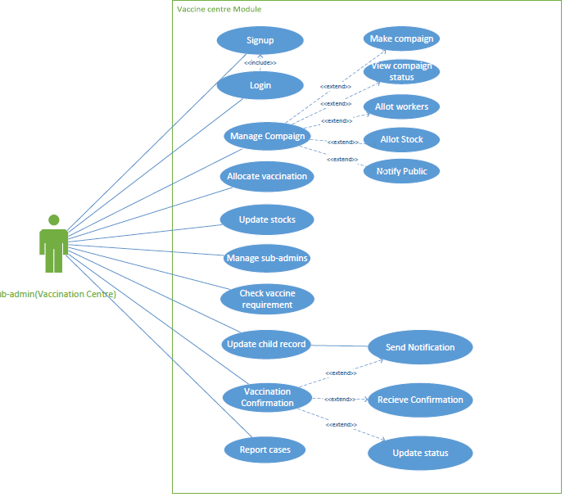

Figure 2: Usecase Sub-admin(Vaccination centre)



Figure 3:Usecase Sub-admin(Polio worker)

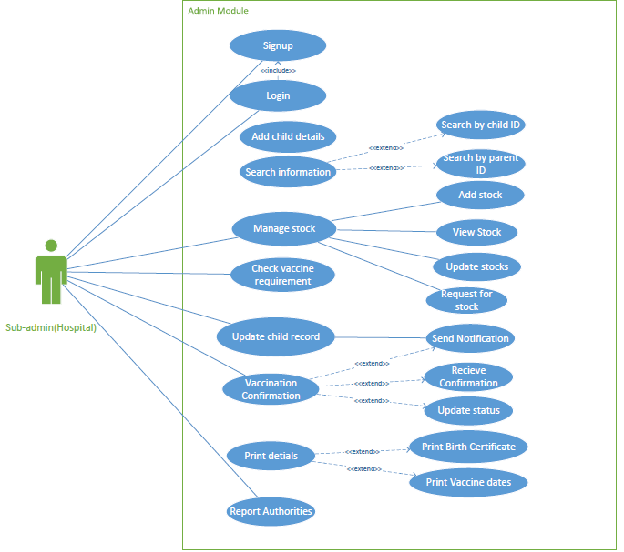

Figure 4:Usecase Sub-admin(Hospital)

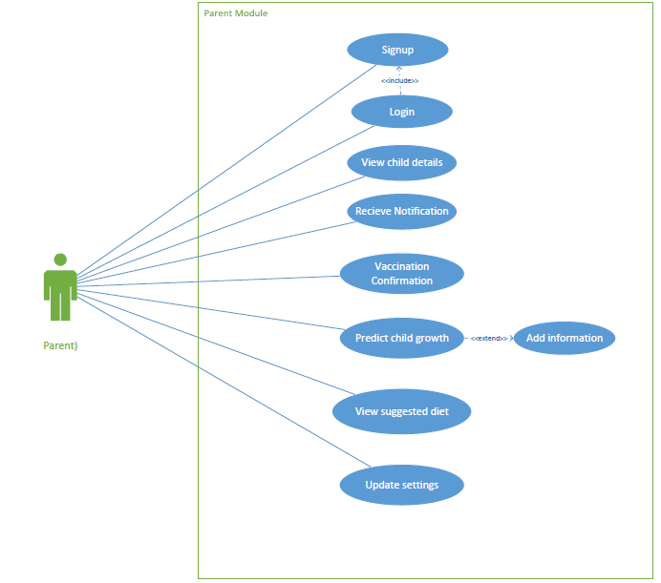

Figure 5:Usecase Sub-admin(Parent)

## Use Case Description

|  |  |
| --- | --- |
| **Use Case ID:** | UC-1 |
| **Use Case Name:** | Login on Web app |
| **Actors:** | Primary Actor: Admin, Hospital, Vaccine Center |
| **Description:** | The user will be able to login and use the application. |
| **Trigger:** | A User will click on “Sign in” to go to the sign in page. |
| **Preconditions:** | PRE-1. User has already accessed to the web page  PRE-2- User already have an account |
| **Post conditions:** | POST-1.User will be given access to fill from to login. |
| **Normal Flow:** | 1. User will type the web URL.  2. User will have option to Log in or Sign up option.  3. User will click on “log in” option.  4. User will select login as admin.  5. The form will be filled by user.  6. User will be logged in to the dashboard. |
| **Alternative Flows:** | N/A |
| **Exceptions:** | 1. If actor does not fill the required fields.  Prompt message will be shown to user to fill in required fields. |
| **Business Rules** | N/A |
| **Assumptions:** | 1. User should be able to access website.  2. User should have registered account. |

Table 1: Textual Description of Admin login

|  |  |
| --- | --- |
| **Use Case ID:** | UC-2 |
| **Use Case Name:** | Prediction |
| **Actors:** | Primary Actor: Admin |
| **Description:** | The admin will open the web application and will select the future prediction option. |
| **Trigger:** | A User will click on Prediction from the dashboard. |
| **Preconditions:** | PRE-1. User has already accessed to the web page  PRE-2- User must be logged in as admin |
| **Post conditions:** | POST-1.User will be given access to the prediction screen. |
| **Normal Flow:** | 1. User will log in to the web application. 2. User will click on future prediction. 3. Another screen will be displayed on screen asking the user to choose between stock prediction and future cases prediction. |
| **Alternative Flows:** | N/A |
| **Exceptions:** | N/A |
| **Business Rules** | N/A |
| **Assumptions:** | 1. User should be able to access website.  2. User must be logged in as admin. |

Table 2: Textual Description of prediction

|  |  |
| --- | --- |
| **Use Case ID:** | UC-3 |
| **Use Case Name:** | Predict Stock |
| **Actors:** | Primary Actor: Admin |
| **Description:** | The admin will select the future prediction option and then will click on Stock Prediction. |
| **Trigger:** | A User will click on Stock Prediction from the prediction screen. |
| **Preconditions:** | PRE-1. User has already accessed to the web page  PRE-2- User must be logged in as admin |
| **Post conditions:** | POST-1.User will be given access to the stock prediction screen. |
| **Normal Flow:** | 1. User will log in to the web application. 2. User will click on future prediction. 3. Another screen will be displayed on screen asking the user to choose between stock prediction and future cases prediction. 4. User will click on stock prediction. |
| **Alternative Flows:** | N/A |
| **Exceptions:** | N/A |
| **Business Rules** | N/A |
| **Assumptions:** | 1. User should be able to access website.  2. User must be logged in as admin. |

**Table 3: Textual Description of stock prediction**

|  |  |
| --- | --- |
| **Use Case ID:** | UC-4 |
| **Use Case Name:** | Predict Stock by area/city |
| **Actors:** | Primary Actor: Admin |
| **Description:** | The admin will select the future prediction option and then will click on Stock Prediction and will select either by area or by city |
| **Trigger:** | A User will click on Stock Prediction from the prediction screen. |
| **Preconditions:** | PRE-1. User has already accessed to the web page  PRE-2- User must be logged in as admin |
| **Post conditions:** | POST-1.User will be given access to the stock prediction screen. |
| **Normal Flow:** | 1. User will log in to the web application. 2. User will click on future prediction. 3. Another screen will be displayed on screen asking the user to choose between stock prediction and future cases prediction. 4. User will click on stock prediction. 5. User will select predict stock by city or by area to see the prediction. |
| **Alternative Flows:** | N/A |
| **Exceptions:** | N/A |
| **Business Rules** | N/A |
| **Assumptions:** | 1. User should be able to access website.  2. User must be logged in as admin. |

Table 4: Textual Description of stock prediction by area/city.

|  |  |
| --- | --- |
| **Use Case ID:** | UC-5 |
| **Use Case Name:** | Predict Cases |
| **Actors:** | Primary Actor: Admin |
| **Description:** | The admin will select the future prediction option and then will click on Cases Prediction. |
| **Trigger:** | A User will click on Cases Prediction from the prediction screen. |
| **Preconditions:** | PRE-1. User has already accessed to the web page  PRE-2- User must be logged in as admin |
| **Post conditions:** | POST-1.User will be given access to the cases prediction screen. |
| **Normal Flow:** | 1. User will log in to the web application. 2. User will click on future prediction. 3. Another screen will be displayed on screen asking the user to choose between stock prediction and future cases prediction. 4. User will click on future case prediction. |
| **Alternative Flows:** | N/A |
| **Exceptions:** | N/A |
| **Business Rules** | N/A |
| **Assumptions:** | 1. User should be able to access website.  2. User must be logged in as admin. |

Table 5: Textual Description of cases prediction

|  |  |
| --- | --- |
| **Use Case ID:** | UC-6 |
| **Use Case Name:** | Predict future cases by area/city |
| **Actors:** | Primary Actor: Admin |
| **Description:** | The admin will select the future prediction option and then will click on future cases Prediction and will select either by area or by city |
| **Trigger:** | A User will click on future cases Prediction from the prediction screen. |
| **Preconditions:** | PRE-1. User has already accessed to the web page  PRE-2- User must be logged in as admin |
| **Post conditions:** | POST-1.User will be given access to the future cases prediction screen. |
| **Normal Flow:** | 1. User will log in to the web application. 2. User will click on future prediction. 3. Another screen will be displayed on screen asking the user to choose between stock prediction and future cases prediction. 4. User will click on future case prediction. 5. User will select predict future cases by city or by area to see the prediction. |
| **Alternative Flows:** | N/A |
| **Exceptions:** | N/A |
| **Business Rules** | N/A |
| **Assumptions:** | 1. User should be able to access website.  2. User must be logged in as admin. |

**Table 6: Textual Description of case prediction by area/city**

|  |  |
| --- | --- |
| **Use Case ID:** | UC-7 |
| **Use Case Name:** | View Stats |
| **Actors:** | Primary Actor: Admin |
| **Description:** | The admin will select view stats from the navbar |
| **Trigger:** | A User will click on view stats from navbar |
| **Preconditions:** | PRE-1. User has already accessed to the web page  PRE-2- User must be logged in as admin |
| **Post conditions:** | POST-1.User will be given access to the statistics screen. |
| **Normal Flow:** | 1. User will log in to the web application. 2. User will click on statistics. 3. Another screen will be displayed on screen where country stats will be show and asking the user to choose between city stats or area stats |
| **Alternative Flows:** | Whole country stats will already be displayed on dashboard from where you can also view stats. |
| **Exceptions:** | Stats will not be shown if there is no data available |
| **Business Rules** | N/A |
| **Assumptions:** | 1. User should be able to access website.  2. User must be logged in as admin. |

**Table 7: Textual Description of view statistics**

|  |  |
| --- | --- |
| **Use Case ID:** | UC-8 |
| **Use Case Name:** | View Stats by city/area |
| **Actors:** | Primary Actor: Admin |
| **Description:** | The admin will select view stats by city or by area from the statistics screen. |
| **Trigger:** | A User will click on view stats from navbar |
| **Preconditions:** | PRE-1. User has already accessed to the web page  PRE-2- User must be logged in as admin |
| **Post conditions:** | POST-1.User will be given access to the statistics screen where statistics will be shown. |
| **Normal Flow:** | 1. User will log in to the web application. 2. User will click on statistics. 3. Another screen will be displayed on screen where country stats will be show and asking the user to choose between city stats or area stats. 4. User will select either city wise or area wise from the screen. |
| **Alternative Flows:** | Whole country stats will already be displayed on dashboard from where you can also view stats. |
| **Exceptions:** | User must not select area where our system is not available. |
| **Business Rules** | N/A |
| **Assumptions:** | 1. User should be able to access website.  2. User must be logged in as admin. |

Table 8: Textual Description of statistics by city/area

|  |  |
| --- | --- |
| **Use Case ID:** | UC-9 |
| **Use Case Name:** | Search Stats |
| **Actors:** | Primary Actor: Admin |
| **Description:** | The admin will select search stats from the statistics screen |
| **Trigger:** | A User will click on search stats |
| **Preconditions:** | PRE-1. User has already accessed to the web page  PRE-2- User must be logged in as admin |
| **Post conditions:** | POST-1.User will be given access to the search statistics screen where you will search stats |
| **Normal Flow:** | 1. User will log in to the web application. 2. User will click on statistics. 3. Statistics screen will be displayed where you can search stats |
| **Alternative Flows:** | Whole country stats will already be displayed on dashboard user can also search stats from there. |
| **Exceptions:** | User must not search area where our system is not available. |
| **Business Rules** | N/A |
| **Assumptions:** | 1. User should be able to access website.  2. User must be logged in as admin. |

Table 9: Textual Description of search statistics

|  |  |
| --- | --- |
| **Use Case ID:** | UC-10 |
| **Use Case Name:** | Search cases or stock info |
| **Actors:** | Primary Actor: Admin |
| **Description:** | The admin will select search stats from the statistics screen |
| **Trigger:** | A User will click on search stats |
| **Preconditions:** | PRE-1. User has already accessed to the web page  PRE-2- User must be logged in as admin |
| **Post conditions:** | POST-1.User will be given access to the search statistics screen where user will search stats |
| **Normal Flow:** | 1. User will log in to the web application. 2. User will click on statistics. 3. Statistics screen will be displayed where you can search stats 4. User will search cases stats or stock info. |
| **Alternative Flows:** | Whole country stats will already be displayed on dashboard you can also search from there. |
| **Exceptions:** | User must not search area where our system is not available. |
| **Business Rules** | N/A |
| **Assumptions:** | 1. User should be able to access website.  2. User must be logged in as admin. |

Table 10: Textual Description of search cases or stock statistics

|  |  |
| --- | --- |
| **Use Case ID:** | UC-11 |
| **Use Case Name:** | Search child info |
| **Actors:** | Primary Actor: Admin |
| **Description:** | The admin will select search child info from the statistics screen |
| **Trigger:** | A User will click on search child info |
| **Preconditions:** | PRE-1. User has already accessed to the web page  PRE-2- User must be logged in as admin |
| **Post conditions:** | POST-1.User will be given access to the search statistics screen where user will search child info |
| **Normal Flow:** | 1. User will log in to the web application. 2. User will click on statistics. 3. Statistics screen will be displayed where you can search stats 4. User will select search child info. 5. User will enter child ID to see his info |
| **Alternative Flows:** | User can also select search child info from navbar |
| **Exceptions:** | User must not search child whose ID is invalid. |
| **Business Rules** | N/A |
| **Assumptions:** | 1. User should be able to access website.  2. User must be logged in as admin. |

Table 11: Textual Description of search specific child stats

|  |  |
| --- | --- |
| **Use Case ID:** | UC-12 |
| **Use Case Name:** | Manage sub admins |
| **Actors:** | Primary Actor: Admin, Polio center |
| **Description:** | The admin will select manage sub admins from the navbar |
| **Trigger:** | A User will click on manage sub admins |
| **Preconditions:** | PRE-1. User has already accessed to the web page  PRE-2- User must be logged in as admin |
| **Post conditions:** | POST-1.User will be given access to the manage sub admins screen where all the admins will be shown |
| **Normal Flow:** | 1. User will log in to the web application. 2. User will click on manage sub admins 3. Statistics screen will be displayed where user will add, remove sub admin or view progress. |
| **Alternative Flows:** | N/A |
| **Exceptions:** | User must not be able to manage sub-admins who are not registered. |
| **Business Rules** | N/A |
| **Assumptions:** | 1. User should be able to access website.  2. User must be logged in as admin. |

Table 12: Textual Description of manage sub admins

**Tabular use cases for Parent:**

|  |  |
| --- | --- |
| **Use Case ID:** | UC-13 |
| **Use Case Name:** | Sign up from mobile app |
| **Actors:** | Primary Actor: Parent, Polio Worker Secondary Actor: Admin |
| **Description:** | The user will be able to Register account and use the application. |
| **Trigger:** | A User will click on “Sign up” to start registering. |
| **Preconditions:** | PRE-1. User has already downloaded the application |
| **Post conditions:** | POST-1.User will be given access to fill from to register account. |
| **Normal Flow:** | 1. User will download application.  2. User will have option to Log in or Sign up option.  3. User will click on “sign up” option.  4. User will select sign up as parent/polio worker.  5. The form will be filled by user.  6. User will be registered. |
| **Alternative Flows:** | N/A |
| **Exceptions:** | 1. If actor does not fill the required fields.  Prompt message will be shown to user to fill in required fields. |
| **Business Rules** | N/A |
| **Assumptions:** | 1. User should be downloaded the application  2. User should have and email account and phone no. |

Table 13: Textual Description of mobile sign up

|  |  |
| --- | --- |
| **Use Case ID:** | UC-14 |
| **Use Case Name:** | Sign in from mobile app |
| **Actors:** | Primary Actor: Parent, Polio Worker Secondary Actor: Admin |
| **Description:** | The user will be able to login and use the application. |
| **Trigger:** | A User will click on “Sign in” to go to the landing page. |
| **Preconditions:** | PRE-1. User has already signed up to the application |
| **Post conditions:** | POST-1.User will be given access to the landing page |
| **Normal Flow:** | 1. User will download application.  2. User will have option to Log in or Sign up option.  3. User will click on “sign in” option.  4. User will the form with email and password.  5. User will be logged in to the landing page. |
| **Alternative Flows:** | N/A |
| **Exceptions:** | 1. If actor does not fill the required fields.  Prompt message will be shown to user to fill in required fields. |
| **Business Rules** | N/A |
| **Assumptions:** | 1. User must be registered. |

Table 14: Textual Description of mobile sign in

|  |  |
| --- | --- |
| **Use Case ID:** | V15 |
| **Use Case Name:** | View child info |
| **Actors:** | Primary Actor: Parent Secondary Actor: Admin |
| **Description:** | The user will be able to see his child info |
| **Trigger:** | A User will click on see child info from the landing page. |
| **Preconditions:** | PRE-1. User has already signed up to the application |
| **Post conditions:** | POST-1.User will be given access to the child info screen where he will enter his ID |
| **Normal Flow:** | 1. User will click in check child info. 2. User will enter his child ID which is written on birth certificate. 3. User will see his child details |
| **Alternative Flows:** | N/A |
| **Exceptions:** | 1. If his child is not registered in our system, details will not be shown. |
| **Business Rules** | N/A |
| **Assumptions:** | 1. User must be registered. 2. Child must also be registered in our system. |

Table 15: Textual Description of View child info

|  |  |
| --- | --- |
| **Use Case ID:** | UC-16 |
| **Use Case Name:** | Vaccination Confirmation |
| **Actors:** | Primary Actor: Parent |
| **Description:** | The user will be able to confirm his child vaccination |
| **Trigger:** | A User will receive notification which he will confirm. |
| **Preconditions:** | PRE-1. User has already signed up to the application |
| **Post conditions:** | POST-1.User will confirm his child vaccination |
| **Normal Flow:** | 1. User will receive notification of his child vaccination. 2. User will confirm it, |
| **Alternative Flows:** | N/A |
| **Exceptions:** | 1. If his child is not registered in our system, no notification will be received. |
| **Business Rules** | N/A |
| **Assumptions:** | 1. User must be registered. 2. Child must also be registered in our system. |

Table 16: Textual Description of Vaccination confirmation

|  |  |
| --- | --- |
| **Use Case ID:** | UC-17 |
| **Use Case Name:** | Check child growth |
| **Actors:** | Primary Actor: Parent |
| **Description:** | The user will be able to check his child growth. |
| **Trigger:** | A User will click on check child growth |
| **Preconditions:** | PRE-1. User has already signed up to the application |
| **Post conditions:** | POST-1.User will be accessed to the growth checking screen where he will enter his child details. |
| **Normal Flow:** | 1. User will click on check child growth. 2. User will enter his child details like height, weight etc. 3. User will click on submit. 4. User will see his child growth. |
| **Alternative Flows:** | N/A |
| **Exceptions:** | N/A |
| **Business Rules** | N/A |
| **Assumptions:** | 1. User must be registered. |

Table 17: Textual Description of check child growth

|  |  |
| --- | --- |
| **Use Case ID:** | UC-18 |
| **Use Case Name:** | View diet plans |
| **Actors:** | Primary Actor: Parent |
| **Description:** | The user will be able to check his child growth and then view the diet plan according to the growth. |
| **Trigger:** | A User will click on see suggested diet. |
| **Preconditions:** | PRE-1. User has already signed up to the application |
| **Post conditions:** | POST-1.User will be accessed to the growth checking screen where he will enter his child details and then see diet plans. |
| **Normal Flow:** | 1. User will click on check child growth. 2. User will enter his child details like height, weight etc. 3. User will click on submit. 4. User will see his child growth. 5. User will click on see suggested diet. 6. Suggested diet will be displayed. |
| **Alternative Flows:** | N/A |
| **Exceptions:** | N/A |
| **Business Rules** | N/A |
| **Assumptions:** | 1. User must be registered. |

Table 18: Textual Description of see diet plans

|  |  |
| --- | --- |
| **Use Case ID:** | UC-19 |
| **Use Case Name:** | Update settings |
| **Actors:** | Primary Actor: Parent |
| **Description:** | The user will be able to update his settings. |
| **Trigger:** | A User will click on settings. |
| **Preconditions:** | PRE-1. User has already signed up to the application |
| **Post conditions:** | POST-1.User will be accessed to the settings screen |
| **Normal Flow:** | 1. User will click on settings. 2. User will update his settings i.e change profile pic, change password etc. |
| **Alternative Flows:** | N/A |
| **Exceptions:** | N/A |
| **Business Rules** | N/A |
| **Assumptions:** | 1. User must be registered. |

Table 19: Textual Description of update profiles

**Use cases of Polio Worker:**

|  |  |
| --- | --- |
| **Use Case ID:** | UC-20 |
| **Use Case Name:** | Update child record |
| **Actors:** | Primary Actor: Polio Worker |
| **Description:** | The user will be able to update child record whose vaccination is done. |
| **Trigger:** | A User will click on update child record. |
| **Preconditions:** | PRE-1. User has already signed up to the application |
| **Post conditions:** | POST-1.User will be able to update child vaccination data |
| **Normal Flow:** | 1. User will click on update child data 2. User will enter updated vaccines info. 3. Notification will be sent to parent 4. Parent will confirm it. 5. Data will be updated. |
| **Alternative Flows:** | N/A |
| **Exceptions:** | N/A |
| **Business Rules** | N/A |
| **Assumptions:** | 1. User must be registered. |

Table 20: Textual Description of update child data

|  |  |
| --- | --- |
| **Use Case ID:** | UC-21 |
| **Use Case Name:** | Report cases |
| **Actors:** | Primary Actor: Polio Worker |
| **Description:** | The user will be able to report authorities about polio cases. |
| **Trigger:** | A User will click on report authorities. |
| **Preconditions:** | PRE-1. User has already signed up to the application |
| **Post conditions:** | POST-1.User will be able to send data to authorities i.e admin |
| **Normal Flow:** | 1. User will click on report authorities 2. User will click on send report 3. A report will be sent to authorities. |
| **Alternative Flows:** | N/A |
| **Exceptions:** | N/A |
| **Business Rules** | N/A |
| **Assumptions:** | 1. User must be registered. |

Table 21: Textual Description of report authorities

|  |  |
| --- | --- |
| **Use Case ID:** | UC-22 |
| **Use Case Name:** | Check Polio symptoms |
| **Actors:** | Primary Actor: Polio Worker Secondary Actor: Parent |
| **Description:** | This will help workers to check Polio symptoms on regular basis |
| **Trigger:** | A User will click on check polio symptoms |
| **Preconditions:** | PRE-1. User has already signed up to the application |
| **Post conditions:** | POST-1.User will be able to get results on polio symptoms |
| **Normal Flow:** | Polio Worker will click on Check polio symptoms  Polio worker will add additional information taken from parents  Polio worker will click on check and results will display |
| **Alternative Flows:** | N/A |
| **Exceptions:** | N/A |
| **Business Rules** | N/A |
| **Assumptions:** | 1. User must be registered. |

Table 22: Textual Description of report authorities

**Tabular Use cases for Hospital:**

|  |  |
| --- | --- |
| **Use Case ID:** | UC-23 |
| **Use Case Name:** | Signup |
| **Actors:** | Primary Actor: Sub-admin(Hospital) |
| **Description:** | The user will be able to Register account and use the application. |
| **Trigger:** | A User will click on “Sign up” to start registering. |
| **Level** | High |
| **Preconditions:** | PRE-1. User has already accessed to the web page |
| **Post conditions:** | POST-1.User will be given access to fill from to register account. |
| **Normal Flow:** | 1. User will type the web URL  2. User will have option to Log in or Sign up option.  3. User will click on “sign up” as hospital.  4. User will select sign up as hospital.  5. The form will be filled by user.  6. User will be registered. |
| **Alternative Flows:** | N/A |
| **Exceptions:** | 1. If actor does not fill the required fields.  Prompt message will be shown to user to fill in required fields. |
| **Business Rules** | N/A |
| **Assumptions:** | 1. User should be able to access website.  2. User should have and email account and phone no. |

**Table 23:Textual Description of hospital sign up**

|  |  |
| --- | --- |
| **Use Case ID:** | UC-24 |
| **Use Case Name:** | Sign in as hospital |
| **Actors:** | Primary Actor: Sub-admin(Hospital) |
| **Description:** | The user will be able to login and use the application. |
| **Trigger:** | A User will click on “Sign in” to go to the landing page. |
| **Level** | High |
| **Preconditions:** | PRE-1. User has already signed up to the application |
| **Post conditions:** | POST-1.User will be given access to fill from to register account. |
| **Normal Flow:** | 1. User will type the web URL or download application.  2. User will have option to Log in or Sign up option.  3. User will click on “sign in” option.  4. User will the form with email and password.  5. User will be logged in to the landing page. |
| **Alternative Flows:** | N/A |
| **Exceptions:** | 1. If actor does not fill the required fields.  Prompt message will be shown to user to fill in required fields. |
| **Business Rules** | N/A |
| **Assumptions:** | 1. Sub-admin must be registered. |

**Table 24: Textual Description of hospital sign in**

|  |  |
| --- | --- |
| **Use Case ID:** | UC-25 |
| **Use Case Name:** | Add child |
| **Actors:** | Primary Actor: Sub-admin(Hospital) |
| **Description:** | User will add all basic information of parent and child |
| **Trigger:** | A user will click on the add child |
| **Level** | High |
| **Preconditions:** | PRE-1. User has already signed in to the application |
| **Post conditions:** | POST-1.User will be able to add a new born child information in the system |
| **Normal Flow:** | 1. User will login his account.  2. User will click on add child.  3. User will fill all the necessary details of parent and child.  4. User will click on submit.  5. User will see the information and code assigned to new baby. |
| **Alternative Flows:** | N/A |
| **Exceptions:** | 1. If actor doesnot fill the required fields.  Prompt message will be shown to user to fill in required fields. |
| **Business Rules** | N/A |
| **Assumptions:** | 1. User must be registered. 2. Child must be a new born baby |

**Table 25: Textual Description of add child**

|  |  |
| --- | --- |
| **Use Case ID:** | UC-26 |
| **Use Case Name:** | Search child |
| **Actors:** | Primary Actor: Sub-admin(Hospital) |
| **Description:** | User will type child name or id and his information will be shown. It will help user to see and update the child record of vaccine. |
| **Trigger:** | A user will click on the add child |
| **Level** | High |
| **Preconditions:** | PRE-1. User has already signed in to the application |
| **Post conditions:** | POST-1.User will be able to view and update the existing child information in the system |
| **Normal Flow:** | 1. User will login his account.  2. User will add id of child in search tab.  3. User will click on search button.  4. Child data will appear and user can see the child information  5. User can select child and update its vaccine information |
| **Alternative Flows:** | User can also search the child through parent id  If parent have multiple child, user can see, select and update it |
| **Exceptions:** | 1. If actor does not fill the required fields.  Prompt message will be shown to user to fill in required fields. |
| **Business Rules** | N/A |
| **Assumptions:** | 1. User must be registered. 2. Child must be a new born baby 3. Child must be registered before |

**Table 26: Textual Description of search child**

|  |  |
| --- | --- |
| **Use Case ID:** | UC-27 |
| **Use Case Name:** | Manage stock (Add or request ) |
| **Actors:** | Primary Actor: Sub-admin(Hospital), Vaccine center |
| **Description:** | User will be able to add or request for vaccine stock to the admin |
| **Trigger:** | A user will click on the manage stock |
| **Level** | High |
| **Preconditions:** | PRE-1. User has already signed in to the application |
| **Post conditions:** | POST-1.User will be able to add a new born child information in the system |
| **Normal Flow:** | 1. User will login his account.  2. User will click on manage stock and will see multiple options there.  3. User will click on the add stock which will be allotted by vaccine center.  4. User will click on add stock and stock will be shown in the record.  5. User can also request for stock to vaccine center or admin |
| **Alternative Flows:** | N/A |
| **Exceptions:** | 1. If actor does not fill the required fields.  Prompt message will be shown to user to fill in required fields.  2. if stock is not allotted then you can’t add |
| **Business Rules** | 1. Stock must be allotted by vaccine center before and its expiry and manufacturing dates should be clearly mentioned 2. This is only valid for the new vaccines like corona etc, for existing vaccines user can only use update information |
| **Assumptions:** | 1. User must be registered. 2. Vaccines are allotted by admin 3. User is adding new vaccines in the system |

**Table 27: Textual Description of manage stock**

|  |  |
| --- | --- |
| **Use Case ID:** | UC-28 |
| **Use Case Name:** | Manage stock (View or update) |
| **Actors:** | Primary Actor: Sub-admin(Hospital), Vaccine center |
| **Description:** | User will be able to view or update the existing vaccines record |
| **Trigger:** | A user will click on the manage stock |
| **Level** | High |
| **Preconditions:** | PRE-1. User has already signed in to the application  PRE-2. Vaccines are already existing in the system |
| **Post conditions:** | POST-1.User will be able to view or update the existing vaccine stock |
| **Normal Flow:** | 1. User will login his account.  2. User will click on manage stock and will see multiple options there.  3. User will click on the view stock and multiple vaccines will be shown there  4. User will click on the specific vaccine which need upgradation  5. User will add new stock information  6. User will click on update stock and stock will be updated  7. User will see the updated stock. |
| **Alternative Flows:** | Same process can be followed in the vaccine center |
| **Exceptions:** | 1. If actor does not fill the required fields.  Prompt message will be shown to user to fill in required fields.  2. if stock is not allotted then you can’t update |
| **Business Rules** | 1. Stock must be allotted by vaccine center before and its expiry and manufacturing dates should be clearly mentioned 2. This is only valid for the existing vaccines. |
| **Assumptions:** | 1. User must be registered. 2. Vaccines are allotted by admin. 3. User is updating new vaccines. |

**Table 28: Textual Description of manage stock**

|  |  |
| --- | --- |
| **Use Case ID:** | UC-29 |
| **Use Case Name:** | Check vaccine requirements |
| **Actors:** | Primary Actor: Sub-admin(Hospital), Vaccine center |
| **Description:** | This is an algorithm based feature which will help the admins to check the upcoming requirement of vaccine in a particular area or hospital |
| **Trigger:** | A user will click check upcoming requirement button |
| **Level** | High |
| **Preconditions:** | PRE-1. All details of new born child and vaccine are already entered in the system |
| **Postconditions:** | POST-1.User will be able to view the upcomiong vaccine stock requirment |
| **Normal Flow:** | 1. User will login his account.  2. User will click on check upcoming requirements of vaccine  3. System at backend will work and check how many children belongs to this area.  4. On this information, system will tell the upcoming requirements of vaccine  5. User will be able to see this  6. User can request to admin for this requirement. |
| **Alternative Flows:** | Same process can be followed in the vaccine center |
| **Exceptions:** | N/A |
| **Business Rules** | This is only valid for the existing vaccines. |
| **Assumptions:** | User must be registered.  Vaccines are allotted by admin. |

**Table 29: Textual Description of vaccine requirements**

|  |  |
| --- | --- |
| **Use Case ID:** | UC-30 |
| **Use Case Name:** | Print details |
| **Actors:** | Primary Actor: Sub-admin(Hospital) |
| **Description:** | Through this feature hospital can give birth certificate and vaccination codes to parents |
| **Trigger:** | A user will click print details |
| **Level** | High |
| **Preconditions:** | PRE-1. All details of new born child is already entered in the system |
| **Post conditions:** | POST-1.User will be able to provide the birth certificate or vaccine details |
| **Normal Flow:** | 1. User will login his account.  2. User will click on print details  3. User can click on print birth certificate  4. A birth certificate will be provided to the end user(Parent).  5. User can click on print vaccine details  6. Vaccine details will be provided to the end user(Parent). |
| **Alternative Flows:** | User can use control + p to print both things |
| **Exceptions:** | N/A |
| **Business Rules** | N/A |
| **Assumptions:** | User must be registered. |

**Table 30: Textual Description of birth certificate**

**Tabular use cases of Vaccine center, Polio center:**

|  |  |
| --- | --- |
| **Use Case ID:** | UC-31 |
| **Use Case Name:** | Manage campaign (Make ) |
| **Actors:** | Primary Actor: Vaccine center, Polio center |
| **Description:** | User will be able to make new vaccine campaigns time to time |
| **Trigger:** | A user will click on the manage campaigns |
| **Level** | High |
| **Preconditions:** | PRE-1. User has already signed in to the application  PRE-2. User is authorized by admin to make these campaigns |
| **Post conditions:** | POST-1.User will be able to make a new campaign of vaccine for general public |
| **Normal Flow:** | 1. User will login his account.  2. User will click on manage campaign.  3. User will click on make new campaign.  4. User will add details like area, starting and ending dates etc  5. User will click on make campaign |
| **Alternative Flows:** | N/A |
| **Exceptions:** | 1. If actor does not fill the required fields.  Prompt message will be shown to user to fill in required fields. |
| **Business Rules** | N/A |
| **Assumptions:** | User must be registered.  Vaccines are allotted by admin  User is authorized by Admin |

**Table 31: Textual Description of manage campaigns**

|  |  |
| --- | --- |
| **Use Case ID:** | UC-32 |
| **Use Case Name:** | Manage campaign (View ) |
| **Actors:** | Primary Actor: Vaccine center, Polio center |
| **Description:** | User will be able to view existing vaccine campaigns. |
| **Trigger:** | A user will click on the manage campaigns |
| **Level** | High |
| **Preconditions:** | PRE-1. User has already signed in to the application  PRE-2. User is authorized by admin to make these campaigns |
| **Post conditions:** | POST-1.User will be able to see the status of existing vaccine campaigns |
| **Normal Flow:** | 1. User will login his account.  2. User will click on manage campaign.  3. User will click View campaigns  4. User will be able to see the status of campaigns running |
| **Alternative Flows:** | N/A |
| **Exceptions:** | 1. If actor does not fill the required fields.  Prompt message will be shown to user to fill in required fields. |
| **Business Rules** | N/A |
| **Assumptions:** | User must be registered.  Vaccines are allotted by admin  User is authorized by Admin |

**Table 32: Textual Description of view campaigns**

|  |  |
| --- | --- |
| **Use Case ID:** | UC-33 |
| **Use Case Name:** | Manage campaign (Allotment) |
| **Actors:** | Primary Actor: Vaccine center, Polio center |
| **Description:** | User will be able to Allot workers and vaccine stock to the campaigns |
| **Trigger:** | A user will click on the manage campaigns |
| **Level** | High |
| **Preconditions:** | PRE-1. User has already signed in to the application  PRE-2. User is authorized by admin to manage these campaigns |
| **Post conditions:** | POST-1.Workers are allotted the area and stock of vaccines |
| **Normal Flow:** | 1. User will login his account.  2. User will click on manage campaign.  3. User will click on the running campaigns  4. User will click on allotment  5. User will allot workers and vaccine stock to the campaigns  6. User will click on the update. |
| **Alternative Flows:** | Same procedure can be done while making campaigns |
| **Exceptions:** | 1. If actor does not fill the required fields.  Prompt message will be shown to user to fill in required fields.  2. User is not authenticated |
| **Business Rules** | N/A |
| **Assumptions:** | N/A |

**Table 33: Textual Description of allot vaccines**

|  |  |
| --- | --- |
| **Use Case ID:** | UC-34 |
| **Use Case Name:** | Manage campaign (Notify) |
| **Actors:** | Primary Actor: Vaccine center, Polio center |
| **Description:** | This feature is to notify the public via sms about the vaccine campaigns so that they can get their children vaccinated |
| **Trigger:** | A user will click on the notify public |
| **Level** | High |
| **Preconditions:** | PRE-1. User has already signed in to the application  PRE-2. User is authorized by admin to manage campaigns |
| **Post conditions:** | POST-1.Parents will receive sms notification about campaigns |
| **Normal Flow:** | 1. User will login his account.  2. User will click on manage campaign.  3. User will click on the running campaigns  4. User will click on notify public.  5. System will send notification to the end users. |
| **Alternative Flows:** | Same procedure can be done while making campaigns |
| **Exceptions:** | 1. User is not authenticated  2. Correct contact numbers are not provided |
| **Business Rules** | N/A |
| **Assumptions:** | N/A |

**Table 34: Textual Description of campaign notifications**

|  |  |
| --- | --- |
| **Use Case ID:** | UC-35 |
| **Use Case Name:** | Allocate stock |
| **Actors:** | Primary Actor: Vaccine center, Polio center |
| **Description:** | User will be able to allot vaccination stock to the sub admins |
| **Trigger:** | A user will click allot stock button |
| **Level** | High |
| **Preconditions:** | PRE-1. User has already signed in to the application  PRE-2. User is authorized by admin to allot these vaccine stock |
| **Post conditions:** | POST-1.Sub-admins are allotted stock of vaccines |
| **Normal Flow:** | 1. User will login his account.  2. User will click allot stock  3. User will fill the details and stock will be allotted  4. User will click on allot and sub-admins can see the allotted stock |
| **Alternative Flows:** | N/A |
| **Exceptions:** | 1. If actor doesnot fill the required fields.  Prompt message will be shown to user to fill in required fields.  2. User is not authenticated |
| **Business Rules** | N/A |
| **Assumptions:** | N/A |

**Table 35: Textual Description of allot stocks**

|  |  |
| --- | --- |
| **Use Case ID:** | UC-36 |
| **Use Case Name:** | Report cases |
| **Actors:** | Primary Actor: Vaccine center, Polio center |
| **Description:** | User will be able report the cases to admins which got unvaccinated |
| **Trigger:** | A user will click on the report to admin button |
| **Level** | High |
| **Preconditions:** | PRE-1. User has already signed in to the application  Pre-2. Parents has been notified many times |
| **Post conditions:** | POST-1.Admin will get the data of such child who didn’t got vaccinated |
| **Normal Flow:** | 1. User will login his account.  2. User will click on report to admin  3. A system generated report will appear in front of user  4. User will click on report. |
| **Alternative Flows:** | N/A |
| **Exceptions:** | N/A |
| **Business Rules** | N/A |
| **Assumptions:** | N/A |

**Table 36: Textual Description of report case**

# Functional Requirements

**Functional Requirements of Admin:**

Table 1: Description of FR-1

|  |  |
| --- | --- |
| **Identifier** | FR-1 |
| **Title** | Login as admin |
| **Requirement** | The user shall be able to login |
| **Source** | Admin, Hospital, Vaccine Center |
| **Rationale** | To login into the system |
| **Business Rule (if required)** | N/A |
| **Dependencies** | N/A |
| **Priority** | High |

Table 2: Description of FR-2

|  |  |
| --- | --- |
| **Identifier** | FR-2 |
| **Title** | Input information |
| **Requirement** | The user shall be able to enter email, password in the required fields to login |
| **Source** | Admin, Hospital, Vaccine Center |
| **Rationale** | User will enter his login information to login into the system |
| **Business Rule (if required)** | N/A |
| **Dependencies** | N/A |
| **Priority** | High |

Table 3: Description of FR-3

|  |  |
| --- | --- |
| **Identifier** | FR-3 |
| **Title** | Check Remember me check box |
| **Requirement** | The user shall be able to check remember me check box. |
| **Source** | Hospital, Admin, Vaccine Center |
| **Rationale** | To check remember me check box so that user will be remembered when he visit the website. |
| **Business Rule (if required)** | N/A |
| **Dependencies** | N/A |
| **Priority** | Low |

Table 4: Description of FR-4

|  |  |
| --- | --- |
| **Identifier** | FR-4 |
| **Title** | Click on Login Button |
| **Requirement** | The user shall be able to click on login button to login to the web application |
| **Source** | Hospital, Vaccine center, admin |
| **Rationale** | To login to the system |
| **Business Rule (if required)** | N/A |
| **Dependencies** | N/A |
| **Priority** | High |

Table 5: Description of FR-5

|  |  |
| --- | --- |
| **Identifier** | FR-5 |
| **Title** | Prediction |
| **Requirement** | The user shall be able to click on prediction tab from nav bar. |
| **Source** | Admin |
| **Rationale** | User will click on prediction to predict future cases and stocks. |
| **Business Rule (if required)** | N/A |
| **Dependencies** | N/A |
| **Priority** | Medium |

Table 6: Description of FR-6

|  |  |
| --- | --- |
| **Identifier** | FR-6 |
| **Title** | Predict Vaccine Stock |
| **Requirement** | The user shall be able to click on predict stock from the prediction screen. |
| **Source** | Admin |
| **Rationale** | To obtain vaccine stock prediction for future needs. |
| **Business Rule (if required)** | N/A |
| **Dependencies** | FR-5 |
| **Priority** | Medium |

Table 7: Description of FR-7

|  |  |
| --- | --- |
| **Identifier** | FR-7 |
| **Title** | Predict future cases |
| **Requirement** | The user shall be able to click on predict future cases from the prediction screen. |
| **Source** | Admin |
| **Rationale** | To obtain future cases prediction. |
| **Business Rule (if required)** | N/A |
| **Dependencies** | FR-5 |
| **Priority** | Medium |

Table 8: Description of FR-8

|  |  |
| --- | --- |
| **Identifier** | FR-8 |
| **Title** | Predict future cases by city, area |
| **Requirement** | The user shall be able to predict cases by city or area from the prediction screen. |
| **Source** | Admin |
| **Rationale** | To obtain future cases prediction by city/area. |
| **Business Rule (if required)** | N/A |
| **Dependencies** | FR-5 |
| **Priority** | Medium |

Table 9: Description of FR-9

|  |  |
| --- | --- |
| **Identifier** | FR-9 |
| **Title** | Predict future stock needs by city, area |
| **Requirement** | The user shall be able to predict future vaccine stock needs by city or area from the stock prediction screen. |
| **Source** | Admin |
| **Rationale** | To obtain future stock needs by city/area. |
| **Business Rule (if required)** | N/A |
| **Dependencies** | FR-5 |
| **Priority** | Medium |

Table 10: Description of FR-10

|  |  |
| --- | --- |
| **Identifier** | FR-10 |
| **Title** | View Stats |
| **Requirement** | The user shall be able to view stats of entire country |
| **Source** | Admin |
| **Rationale** | To view stats of entire country. |
| **Business Rule (if required)** | N/A |
| **Dependencies** | N/A |
| **Priority** | medium |

Table 11: Description of FR-11

|  |  |
| --- | --- |
| **Identifier** | FR-11 |
| **Title** | View Stats by city/area |
| **Requirement** | The user shall be able to view stats of specific city or area. |
| **Source** | Admin |
| **Rationale** | To view stats of specific city or area. |
| **Business Rule (if required)** | N/A |
| **Dependencies** | FR-10 |
| **Priority** | medium |

Table 12: Description of FR-12

|  |  |
| --- | --- |
| **Identifier** | FR-12 |
| **Title** | Search Stats |
| **Requirement** | The user will click on search stats to search. |
| **Source** | Admin |
| **Rationale** | To search stats. |
| **Business Rule (if required)** | N/A |
| **Dependencies** | N/A |
| **Priority** | Low |

Table 13: Description of FR-13

|  |  |
| --- | --- |
| **Identifier** | FR-13 |
| **Title** | Search Stock by city/area |
| **Requirement** | The user will click on search stock stats from the search screen |
| **Source** | Admin |
| **Rationale** | To search stock stats by city/area. |
| **Business Rule (if required)** | N/A |
| **Dependencies** | N/A |
| **Priority** | low |

Table 14: Description of FR-14

|  |  |
| --- | --- |
| **Identifier** | FR-14 |
| **Title** | Search Cases by city/area |
| **Requirement** | The user will click on search cases stats from the search screen |
| **Source** | Admin |
| **Rationale** | To search cases stats by city/area. |
| **Business Rule (if required)** | N/A |
| **Dependencies** | N/A |
| **Priority** | low |

Table 15: Description of FR-15

|  |  |
| --- | --- |
| **Identifier** | FR-15 |
| **Title** | Search child info |
| **Requirement** | The user will click on search child info from the search screen |
| **Source** | Admin |
| **Rationale** | To search child vaccination info by entering his ID to the search field. |
| **Business Rule (if required)** | N/A |
| **Dependencies** | N/A |
| **Priority** | low |

Table 16: Description of FR-16

|  |  |
| --- | --- |
| **Identifier** | FR-16 |
| **Title** | Manage sub admins |
| **Requirement** | The user will click on manage sub admins. |
| **Source** | Admin |
| **Rationale** | To manage sub admins. |
| **Business Rule (if required)** | N/A |
| **Dependencies** | N/A |
| **Priority** | low |

Table 17: Description of FR-17

|  |  |
| --- | --- |
| **Identifier** | FR-17 |
| **Title** | Add sub admin |
| **Requirement** | The user will add new sub admin from manage admin screen. |
| **Source** | Admin |
| **Rationale** | To add new sub admins from the system. |
| **Business Rule (if required)** | N/A |
| **Dependencies** | N/A |
| **Priority** | low |

Table 18: Description of FR-18

|  |  |
| --- | --- |
| **Identifier** | FR-18 |
| **Title** | Remove sub admin |
| **Requirement** | The user will remove sub admin from manage admin screen. |
| **Source** | Admin |
| **Rationale** | To remove sub admins from the system. |
| **Business Rule (if required)** | N/A |
| **Dependencies** | N/A |
| **Priority** | low |

Table 19: Description of FR-19

|  |  |
| --- | --- |
| **Identifier** | FR-19 |
| **Title** | View sub admin progress |
| **Requirement** | The user will view sub admin progress. |
| **Source** | Admin |
| **Rationale** | To view sub admin progress by click on sub admin name from manage sub admins screen. |
| **Business Rule (if required)** | N/A |
| **Dependencies** | N/A |
| **Priority** | low |

**Functional Requirements of Parent:**

Table 20: Description of FR-20

|  |  |
| --- | --- |
| **Identifier** | FR-20 |
| **Title** | Sign up |
| **Requirement** | The user will click on sign up to register to the application. |
| **Source** | Hospital, Polio worker |
| **Rationale** | To Register account. |
| **Business Rule (if required)** | N/A |
| **Dependencies** | N/A |
| **Priority** | High |

Table 21: Description of FR-21

|  |  |
| --- | --- |
| **Identifier** | FR-21 |
| **Title** | Fill information |
| **Requirement** | The user shall be able to fill information in the input fields |
| **Source** | Hospital, Polio worker |
| **Rationale** | To input information of user i.e name, email, password etc. |
| **Business Rule (if required)** | N/A |
| **Dependencies** | N/A |
| **Priority** | High |

Table 22: Description of FR-22

|  |  |
| --- | --- |
| **Identifier** | FR-22 |
| **Title** | Sign up Button |
| **Requirement** | The user shall be able to click on sign up button to register. |
| **Source** | Hospital, Polio worker |
| **Rationale** | To Register account by clicking on sign up |
| **Business Rule (if required)** | N/A |
| **Dependencies** | N/A |
| **Priority** | High |

Table 23: Description of FR-23

|  |  |
| --- | --- |
| **Identifier** | FR-23 |
| **Title** | Login button |
| **Requirement** | The user shall be able to click on login button if he already have an account. |
| **Source** | Hospital, Polio worker |
| **Rationale** | To Login into the system if user already have an account |
| **Business Rule (if required)** | N/A |
| **Dependencies** | N/A |
| **Priority** | Low |

Table 24: Description of FR-24

|  |  |
| --- | --- |
| **Identifier** | FR-24 |
| **Title** | Login |
| **Requirement** | The user shall be able to login from mobile app |
| **Source** | Parent, Polio worker |
| **Rationale** | To login into the system from mobile application |
| **Business Rule (if required)** | N/A |
| **Dependencies** | N/A |
| **Priority** | low |

Table 25: Description of FR-25

|  |  |
| --- | --- |
| **Identifier** | FR-25 |
| **Title** | Input information |
| **Requirement** | The user shall be able to enter email, password in the required fields to login from mobile app |
| **Source** | Parent, Polio worker |
| **Rationale** | User will enter his login information to login into the system from mobile app. |
| **Business Rule (if required)** | N/A |
| **Dependencies** | N/A |
| **Priority** | low |

Table 26: Description of FR-26

|  |  |
| --- | --- |
| **Identifier** | FR-26 |
| **Title** | Check Remember me check box |
| **Requirement** | The user shall be able to check remember me check box. |
| **Source** | Parent, Polio worker |
| **Rationale** | To check remember me check box so that user will be remembered when he open the mobile app. |
| **Business Rule (if required)** | N/A |
| **Dependencies** | N/A |
| **Priority** | low |

Table 27: Description of FR-27

|  |  |
| --- | --- |
| **Identifier** | FR-27 |
| **Title** | Click on Login Button |
| **Requirement** | The user shall be able to click on login button to login to the mobile application |
| **Source** | Parent, Polio worker |
| **Rationale** | To login to the system from mobile app |
| **Business Rule (if required)** | N/A |
| **Dependencies** | N/A |
| **Priority** | High |

Table 28: Description of FR-28

|  |  |
| --- | --- |
| **Identifier** | FR-28 |
| **Title** | Click on View child details |
| **Requirement** | The user shall be able to click on view child details to view his child information |
| **Source** | Parent |
| **Rationale** | To view the child vaccination and other details |
| **Business Rule (if required)** | N/A |
| **Dependencies** | N/A |
| **Priority** | medium |

Table 29: Description of FR-29

|  |  |
| --- | --- |
| **Identifier** | FR-29 |
| **Title** | Enter child ID |
| **Requirement** | The user shall be able to enter his child ID to view his details |
| **Source** | Parent |
| **Rationale** | To enter child ID to view his details. |
| **Business Rule (if required)** | N/A |
| **Dependencies** | N/A |
| **Priority** | medium |

Table 30: Description of FR-30

|  |  |
| --- | --- |
| **Identifier** | FR-30 |
| **Title** | Receive notifications |
| **Requirement** | The user shall be able to receive notifications when vaccine center will update his child info. |
| **Source** | Parent |
| **Rationale** | To receive notifications. |
| **Business Rule (if required)** | N/A |
| **Dependencies** | N/A |
| **Priority** | medium |

|  |  |
| --- | --- |
| **Identifier** | FR-31 |
| **Title** | Confirm vaccinations |
| **Requirement** | The user shall be able to confirm vaccination of his child. |
| **Source** | Parent |
| **Rationale** | To confirm vaccination. |
| **Business Rule (if required)** | N/A |
| **Dependencies** | N/A |
| **Priority** | medium |

|  |  |
| --- | --- |
| **Identifier** | FR-32 |
| **Title** | Check child growth |
| **Requirement** | The user shall be able to click on check child growth. |
| **Source** | Parent |
| **Rationale** | To check growth of child. |
| **Business Rule (if required)** | N/A |
| **Dependencies** | N/A |
| **Priority** | low |

|  |  |
| --- | --- |
| **Identifier** | FR-33 |
| **Title** | Fill information |
| **Requirement** | The user shall be able to fill his child information to check his child growth |
| **Source** | Parent |
| **Rationale** | To fill child info to see child growth |
| **Business Rule (if required)** | N/A |
| **Dependencies** | N/A |
| **Priority** | low |

|  |  |
| --- | --- |
| **Identifier** | FR-34 |
| **Title** | Click submit |
| **Requirement** | The user shall be able to click on submit to see his child growth. |
| **Source** | Parent |
| **Rationale** | To click on submit to check growth of child. |
| **Business Rule (if required)** | N/A |
| **Dependencies** | N/A |
| **Priority** | low |

|  |  |
| --- | --- |
| **Identifier** | FR-35 |
| **Title** | View suggested diet |
| **Requirement** | The user shall be able to click on view suggested diet from child growth screen |
| **Source** | Parent |
| **Rationale** | To click on view suggested diets to view diet |
| **Business Rule (if required)** | N/A |
| **Dependencies** | N/A |
| **Priority** | low |

|  |  |
| --- | --- |
| **Identifier** | FR-36 |
| **Title** | Update settings |
| **Requirement** | The user shall be able to click on settings to update his user settings |
| **Source** | Parent, Polio worker |
| **Rationale** | To click on settings to update his settings |
| **Business Rule (if required)** | N/A |
| **Dependencies** | N/A |
| **Priority** | low |

|  |  |
| --- | --- |
| **Identifier** | FR-37 |
| **Title** | Update password |
| **Requirement** | The user shall be able to click on update password from settings |
| **Source** | Parent, Polio worker |
| **Rationale** | To click on update password from settings to update password. |
| **Business Rule (if required)** | N/A |
| **Dependencies** | N/A |
| **Priority** | low |

|  |  |
| --- | --- |
| **Identifier** | FR-38 |
| **Title** | Add new password |
| **Requirement** | The user shall be able to add new password from the update password screen. |
| **Source** | Parent, Polio worker |
| **Rationale** | To fill update password fields to update password. |
| **Business Rule (if required)** | N/A |
| **Dependencies** | N/A |
| **Priority** | low |

**Functional Requirements of Polio Worker:**

|  |  |
| --- | --- |
| **Identifier** | FR-39 |
| **Title** | Update child record |
| **Requirement** | The user shall be able to update child vaccination record. |
| **Source** | Polio worker |
| **Rationale** | To update child vaccination record. |
| **Business Rule (if required)** | N/A |
| **Dependencies** | N/A |
| **Priority** | low |

|  |  |
| --- | --- |
| **Identifier** | FR-40 |
| **Title** | Send notifications |
| **Requirement** | The user shall be able to send notifications when he updates child vaccination record. |
| **Source** | Polio worker |
| **Rationale** | To send notification to parent. |
| **Business Rule (if required)** | N/A |
| **Dependencies** | FR-39 |
| **Priority** | low |

|  |  |
| --- | --- |
| **Identifier** | FR-41 |
| **Title** | Receive confirmation |
| **Requirement** | The user shall be able to receive confirmation of vaccination from parent when he updates the child vaccination info. |
| **Source** | Polio worker |
| **Rationale** | To receive confirmation of vaccination from parent. |
| **Business Rule (if required)** | N/A |
| **Dependencies** | FR-39 |
| **Priority** | low |

|  |  |
| --- | --- |
| **Identifier** | FR-42 |
| **Title** | Update status |
| **Requirement** | The user shall be able to update child vaccination status when the parents confirm vaccination. |
| **Source** | Polio worker |
| **Rationale** | To update child vaccination status when parent confirms vaccination. |
| **Business Rule (if required)** | N/A |
| **Dependencies** | FR-39 |
| **Priority** | low |

|  |  |
| --- | --- |
| **Identifier** | FR-43 |
| **Title** | Report cases |
| **Requirement** | The user shall be able to report authorities about polio cases. |
| **Source** | Polio worker |
| **Rationale** | To report authorities about polio cases. |
| **Business Rule (if required)** | N/A |
| **Dependencies** | N/A |
| **Priority** | low |

|  |  |
| --- | --- |
| **Identifier** | FR-44 |
| **Title** | Get Symptoms Data |
| **Requirement** | The user shall be able to add symptoms data in system |
| **Source** | Polio worker |
| **Rationale** | To check polio symptoms |
| **Business Rule (if required)** | N/A |
| **Dependencies** | N/A |
| **Priority** | low |

|  |  |
| --- | --- |
| **Identifier** | FR-45 |
| **Title** | Check Symptoms |
| **Requirement** | The user shall be able to check symptoms through system |
| **Source** | Polio worker |
| **Rationale** | To check polio symptoms |
| **Business Rule (if required)** | N/A |
| **Dependencies** | N/A |
| **Priority** | Low |

**Functional Requirements of sub-admin (Hospital):**

|  |  |
| --- | --- |
| **Identifier** | FR-46 |
| **Title** | Sign up from web app. |
| **Requirement** | The user shall be able to click on sign up from web application |
| **Source** | Hospital, Vaccination center |
| **Rationale** | To Register account as hospital, vaccination center |
| **Business Rule (if required)** | N/A |
| **Dependencies** | N/A |
| **Priority** | High |

|  |  |
| --- | --- |
| **Identifier** | FR-47 |
| **Title** | Fill information |
| **Requirement** | The user shall be able to fill information for sign up |
| **Source** | Hospital, Vaccination center |
| **Rationale** | To fill information about sign up like name, email, password etc |
| **Business Rule (if required)** | N/A |
| **Dependencies** | N/A |
| **Priority** | High |

|  |  |
| --- | --- |
| **Identifier** | FR-48 |
| **Title** | Sign up Button |
| **Requirement** | The user shall be able to click on sign up button to register. |
| **Source** | Hospital, Vaccination center |
| **Rationale** | To Register account. |
| **Business Rule (if required)** | N/A |
| **Dependencies** | N/A |
| **Priority** | High |

|  |  |
| --- | --- |
| **Identifier** | FR-49 |
| **Title** | Login button |
| **Requirement** | The user shall be able to click on login button if he already have an account. |
| **Source** | Hospital, Vaccination center |
| **Rationale** | To Login account if user already have an account. |
| **Business Rule (if required)** | N/A |
| **Dependencies** | N/A |
| **Priority** | Low |

|  |  |
| --- | --- |
| **Identifier** | FR-50 |
| **Title** | Click on add child record Button |
| **Requirement** | The user shall be able to click on add child record to add record of newly born child |
| **Source** | Hospital |
| **Rationale** | To enter record of newly born child into the system. |
| **Business Rule (if required)** | N/A |
| **Dependencies** | N/A |
| **Priority** | High |

|  |  |
| --- | --- |
| **Identifier** | FR-51 |
| **Title** | Enter child details |
| **Requirement** | The user shall be able to enter details of newly born child |
| **Source** | Hospital |
| **Rationale** | To enter record of newly born child like date of birth, time, father CNIC etc. |
| **Business Rule (if required)** | N/A |
| **Dependencies** | N/A |
| **Priority** | High |

|  |  |
| --- | --- |
| **Identifier** | FR-52 |
| **Title** | Submit child record |
| **Requirement** | The user shall be able to click on submit button to add record of newly born child |
| **Source** | Hospital |
| **Rationale** | To submit record into the database. |
| **Business Rule (if required)** | N/A |
| **Dependencies** | FR-49 |
| **Priority** | High |

|  |  |
| --- | --- |
| **Identifier** | FR-53 |
| **Title** | Click on update child record Button |
| **Requirement** | The user shall be able to click on update child record to update record of newly born child |
| **Source** | Hospital |
| **Rationale** | To update record of newly born child i.e name. |
| **Business Rule (if required)** | N/A |
| **Dependencies** | FR-50 |
| **Priority** | Low |

|  |  |
| --- | --- |
| **Identifier** | FR-54 |
| **Title** | Enter id of child |
| **Requirement** | The user shall be able to enter ID of child to update child record. |
| **Source** | Hospital |
| **Rationale** | To update record of newly born child. |
| **Business Rule (if required)** | N/A |
| **Dependencies** | FR-50 |
| **Priority** | Low |

|  |  |
| --- | --- |
| **Identifier** | FR-55 |
| **Title** | Enter updated child details |
| **Requirement** | The user shall be able to enter updated details of a child |
| **Source** | Hospital |
| **Rationale** | To update record of newly born child. |
| **Business Rule (if required)** | N/A |
| **Dependencies** | FR-50 |
| **Priority** | medium |

|  |  |
| --- | --- |
| **Identifier** | FR-56 |
| **Title** | Submit updated child record |
| **Requirement** | The user shall be able to click on update record button to update record of newly born child |
| **Source** | Hospital |
| **Rationale** | To update record of newly born child. |
| **Business Rule (if required)** | N/A |
| **Dependencies** | FR-50 |
| **Priority** | Low |

|  |  |
| --- | --- |
| **Identifier** | FR-57 |
| **Title** | Click on print birth certificate button |
| **Requirement** | The user shall be able to click on print birth certificate button to print birth certificate of newly born child |
| **Source** | Hospital |
| **Rationale** | To print birth certificate of newly born child. |
| **Business Rule (if required)** | N/A |
| **Dependencies** | FR-50 |
| **Priority** | High |

|  |  |
| --- | --- |
| **Identifier** | FR-58 |
| **Title** | Adjust print options |
| **Requirement** | The user shall be able to adjust print options |
| **Source** | Hospital |
| **Rationale** | To print birth certificate of newly born child. |
| **Business Rule (if required)** | N/A |
| **Dependencies** | FR-50 |
| **Priority** | Low |

|  |  |
| --- | --- |
| **Identifier** | FR-59 |
| **Title** | Click on print |
| **Requirement** | The user shall be able to click on print button to print birth certificate. |
| **Source** | Hospital |
| **Rationale** | To print birth certificate of newly born child. |
| **Business Rule (if required)** | N/A |
| **Dependencies** | FR-50 |
| **Priority** | High |

|  |  |
| --- | --- |
| **Identifier** | FR-60 |
| **Title** | Click on print vaccination dates button |
| **Requirement** | The user shall be able to click on print vaccination dates button to print auto generated vaccination dates of newly born child |
| **Source** | Hospital |
| **Rationale** | To print vaccination dates of newly born child. |
| **Business Rule (if required)** | N/A |
| **Dependencies** | FR-50 |
| **Priority** | high |

|  |  |
| --- | --- |
| **Identifier** | FR-61 |
| **Title** | Search child information |
| **Requirement** | The user shall be able to click on search child information to search child information by ID. |
| **Source** | Hospital |
| **Rationale** | To search specific child info by their ID. |
| **Business Rule (if required)** | N/A |
| **Dependencies** | N/A |
| **Priority** | Low |

|  |  |
| --- | --- |
| **Identifier** | FR-62 |
| **Title** | Check vaccine requirements |
| **Requirement** | The user shall be able to click on vaccine requirements to check future requirements of vaccine. |
| **Source** | Hospital, Vaccine center |
| **Rationale** | To check future vaccine requirements. |
| **Business Rule (if required)** | N/A |
| **Dependencies** | N/A |
| **Priority** | Low |

|  |  |
| --- | --- |
| **Identifier** | FR-63 |
| **Title** | Update child vaccination record |
| **Requirement** | The user shall be able to update child vaccination record from web application. |
| **Source** | Hospital, Vaccine center |
| **Rationale** | To update child vaccination record. |
| **Business Rule (if required)** | N/A |
| **Dependencies** | FR-50 |
| **Priority** | High |

|  |  |
| --- | --- |
| **Identifier** | FR-64 |
| **Title** | Send notifications |
| **Requirement** | The user shall be able to send notifications when he updates child vaccination record. |
| **Source** | Hospital, Vaccine center |
| **Rationale** | To send notification to parent. |
| **Business Rule (if required)** | N/A |
| **Dependencies** | FR-50 |
| **Priority** | Low |

|  |  |
| --- | --- |
| **Identifier** | FR-65 |
| **Title** | Receive confirmation |
| **Requirement** | The user shall be able to receive confirmation of vaccination from parent when he updates the child vaccination info. |
| **Source** | Hospital, Vaccine center |
| **Rationale** | To receive confirmation of vaccination from parent. |
| **Business Rule (if required)** | N/A |
| **Dependencies** | FR-50 |
| **Priority** | Low |

|  |  |
| --- | --- |
| **Identifier** | FR-66 |
| **Title** | Update status |
| **Requirement** | The user shall be able to update child vaccination status when the parents confirm vaccination. |
| **Source** | Hospital, Vaccine center |
| **Rationale** | To update child vaccination status when parent confirms vaccination. |
| **Business Rule (if required)** | N/A |
| **Dependencies** | FR-50 |
| **Priority** | Low |

|  |  |
| --- | --- |
| **Identifier** | FR-67 |
| **Title** | Report authorities |
| **Requirement** | The user shall be able to report authorities about polio cases. |
| **Source** | Hospital, Vaccine center |
| **Rationale** | To report authorities about polio cases. |
| **Business Rule (if required)** | N/A |
| **Dependencies** | N/A |
| **Priority** | Low |

|  |  |
| --- | --- |
| **Identifier** | FR-68 |
| **Title** | Manage vaccine stock |
| **Requirement** | The user shall be able to click on manage vaccine stock. |
| **Source** | Hospital, Vaccine center |
| **Rationale** | To manage vaccine stock. |
| **Business Rule (if required)** | N/A |
| **Dependencies** | N/A |
| **Priority** | Low |

|  |  |
| --- | --- |
| **Identifier** | FR-69 |
| **Title** | Add stock |
| **Requirement** | The user shall be able to click on Add vaccine stock |
| **Source** | Hospital, Vaccine center |
| **Rationale** | To add new vaccine stock |
| **Business Rule (if required)** | N/A |
| **Dependencies** | N/A |
| **Priority** | Low |

|  |  |
| --- | --- |
| **Identifier** | FR-70 |
| **Title** | update stock |
| **Requirement** | The user shall be able to click on update vaccine stock |
| **Source** | Hospital, Vaccine center |
| **Rationale** | To update vaccine stock |
| **Business Rule (if required)** | N/A |
| **Dependencies** | N/A |
| **Priority** | Low |

|  |  |
| --- | --- |
| **Identifier** | FR-71 |
| **Title** | View stock |
| **Requirement** | The user shall be able to click on view vaccine stock |
| **Source** | Hospital, Vaccine center |
| **Rationale** | To view vaccine stock |
| **Business Rule (if required)** | N/A |
| **Dependencies** | N/A |
| **Priority** | Low |

|  |  |
| --- | --- |
| **Identifier** | FR-72 |
| **Title** | Request for stock |
| **Requirement** | The user shall be able to click on request more stock from the higher authorities |
| **Source** | Hospital |
| **Rationale** | To request for more vaccine stock |
| **Business Rule (if required)** | N/A |
| **Dependencies** | N/A |
| **Priority** | Low |

**Functional Requirements for Vaccination Center:**

|  |  |
| --- | --- |
| **Identifier** | FR-73 |
| **Title** | Manage campaigns |
| **Requirement** | The user shall be able to click on manage vaccine campaigns to manage new campaigns |
| **Source** | Vaccine center |
| **Rationale** | To manage campaigns |
| **Business Rule (if required)** | N/A |
| **Dependencies** | N/A |
| **Priority** | Low |

|  |  |
| --- | --- |
| **Identifier** | FR-74 |
| **Title** | Make new campaigns |
| **Requirement** | The user shall be able to click on make new campaign to initiate new campaign |
| **Source** | Vaccine center |
| **Rationale** | To make new campaigns |
| **Business Rule (if required)** | N/A |
| **Dependencies** | N/A |
| **Priority** | Low |

|  |  |
| --- | --- |
| **Identifier** | FR-75 |
| **Title** | View campaign status |
| **Requirement** | The user shall be able to click on any campaign to view their status |
| **Source** | Vaccine center |
| **Rationale** | To view existing campaign status |
| **Business Rule (if required)** | N/A |
| **Dependencies** | N/A |
| **Priority** | Low |

|  |  |
| --- | --- |
| **Identifier** | FR-76 |
| **Title** | Allot workers for campaign |
| **Requirement** | The user shall be able allot worker for campaigns |
| **Source** | Vaccine center |
| **Rationale** | To allot worker for new campaigns |
| **Business Rule (if required)** | N/A |
| **Dependencies** | N/A |
| **Priority** | Low |

|  |  |
| --- | --- |
| **Identifier** | FR-77 |
| **Title** | Allot vaccine for campaign |
| **Requirement** | The user shall be able allot vaccine for campaigns |
| **Source** | Vaccine center |
| **Rationale** | To allot vaccine for new campaigns |
| **Business Rule (if required)** | N/A |
| **Dependencies** | N/A |
| **Priority** | Low |

|  |  |
| --- | --- |
| **Identifier** | FR-78 |
| **Title** | Notify public |
| **Requirement** | The user shall be able to notify public by sending them text messages |
| **Source** | Vaccine center |
| **Rationale** | To notify public by sending text messages to already registered users. |
| **Business Rule (if required)** | N/A |
| **Dependencies** | N/A |
| **Priority** | Low |

# Non-Functional Requirements

## Reliability

REA-1: Parent and child data should be added accurately as whole system is build on this single thing

REA-2: Admin approval is important for all the work done

## Usability

*USE-1:* The system must allow user to see his child vaccine data with only one click

*USE-2:* The system shall provide information for comforming notification

*USE-3:* The system shall work in those areas too where internet facility is not good

## Accessibility

*ACC-1-* It must be accessible from remote areas. It must be accessible through mobile and web efficiently

## Compatible

*COM-1-* The system shall be compatible with both Android and iOS. Web should be easily compatible on all major browsers

## Security

SEC-1: Security in this system should be very high as it contains sensitive information.

# External Interface Requirements

## User Interfaces

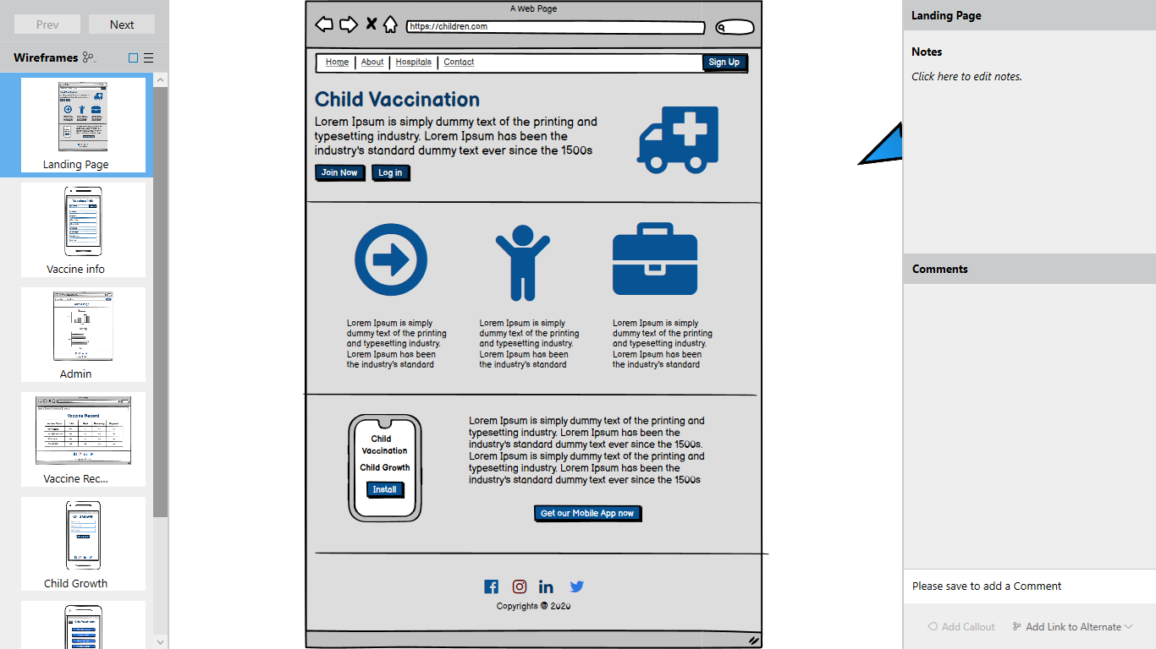

Figure 3: Mock 1

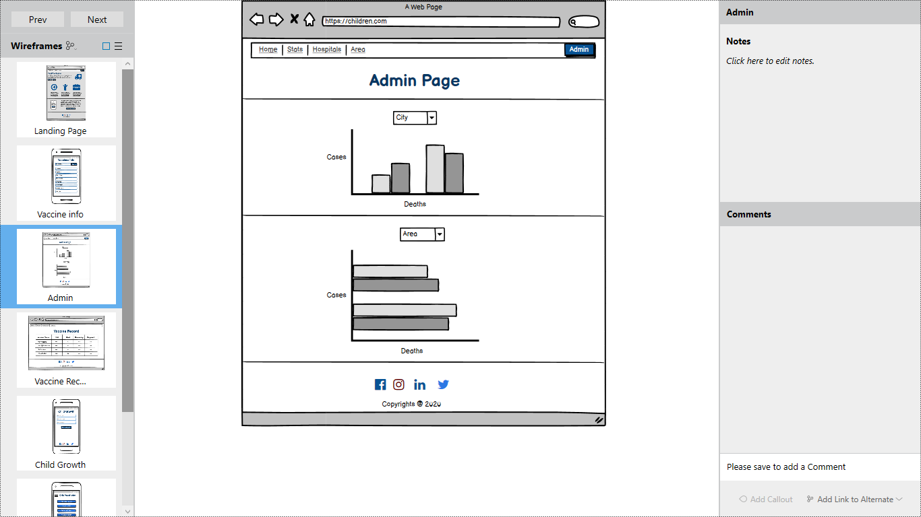

Figure 4: Mock 2

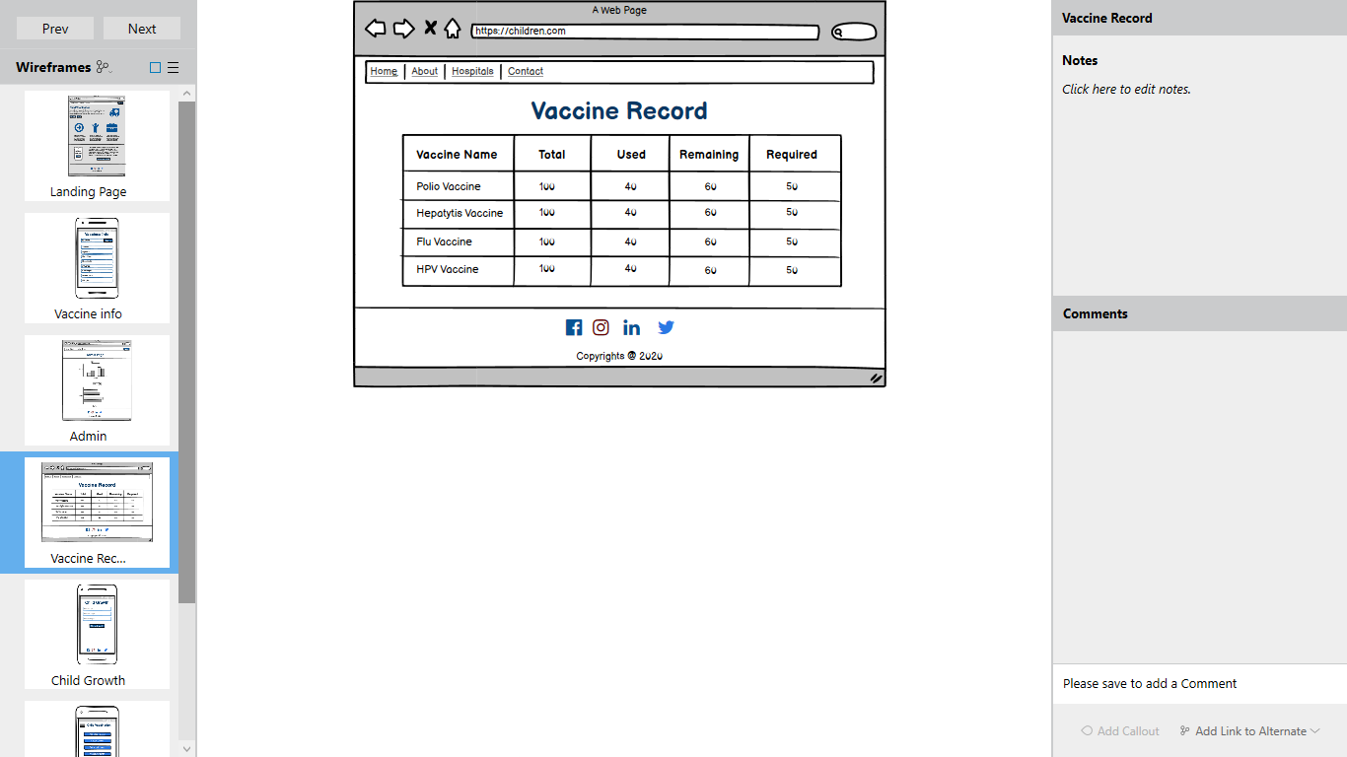

Figure 5: Mock 3

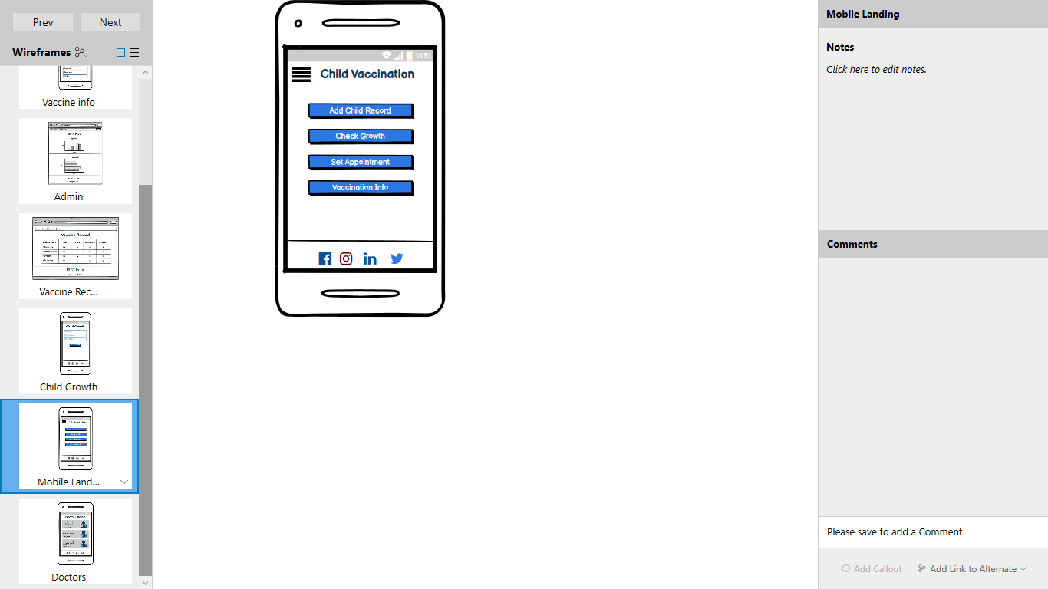

Figure 6: Mock 4

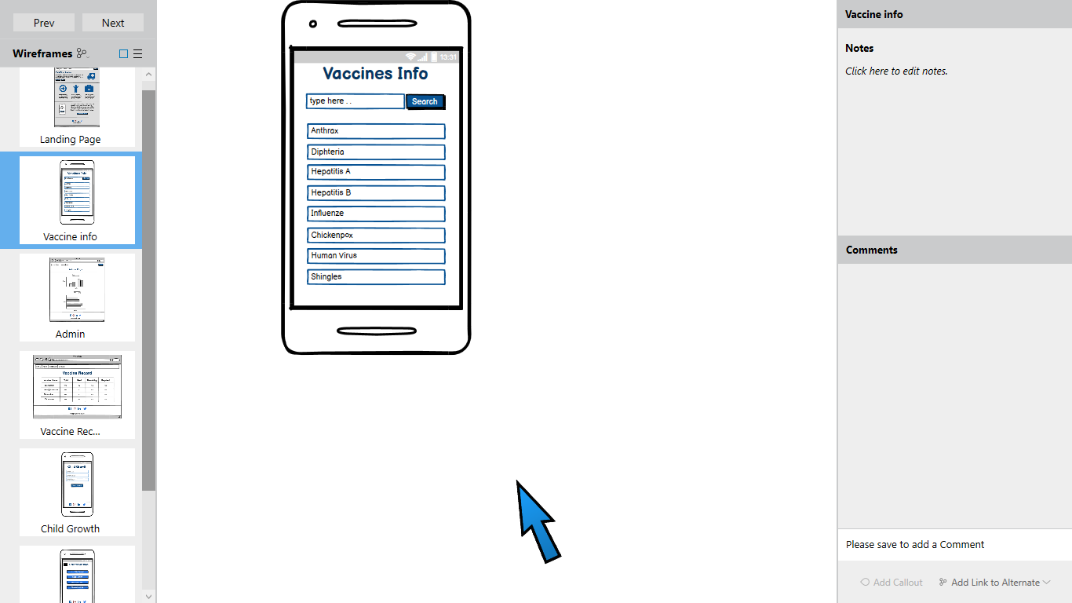

Figure 7: Mock 5

## Software Interfaces

SI-I: The developers shall use Visual Studio Code as the code editor for application development.

SI-II: The system shall use a NoSQL Database i.e. Mongo DB for storing, maintaining and retrieving user records.

SI-III: The system shall support Android OS and iOS for this mobile application.

## Hardware Interfaces

This system is not using any hardware interface right now

## Communication Interfaces

There is no communication interface in our project

# Project Gantt Chart

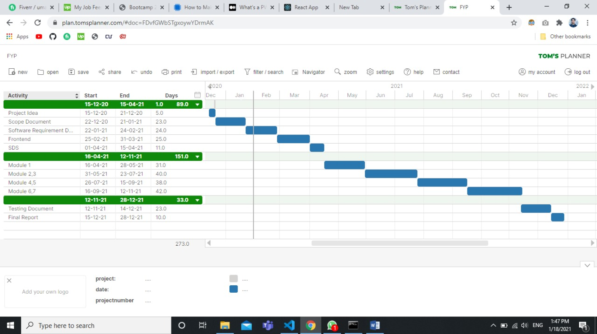

Figure 8: Gantt Chart

# Conclusion

As name of our project is explaining that this system is related to child vaccination and growth tracking so in this document we have mentioned all the specific requirements of our project with actor wise diagrams. We have mentioned all the features which this system will provide. Mocks are also present to give an idea about interfaces.

# References

# Plagiarism Report

